New Information is in Blue Text
Event Name | Caldor Fire: 08242021-163
Date | 09/05/2021 1700
Report Number | 16
Duty Officer – 775-687-0498: Rodney Wright
Current Situation
Governor Sisolak has signed a Declaration of Emergency and the Douglas County Board of Commissioners has declared a State of Emergency in response to the Caldor Fire. As of 1530 the containment of the fire is at 44%. Acres burned is at 215,400. The Evacuation orders in areas of El Dorado County, California had resulted in road closures and shelters opening within Nevada.
Mandatory evacuations in Douglas County, NV have been downgraded to precautionary warnings. South Lake Tahoe still closed to non-essential travel. All residents and workers for Nevada are allowed to repopulate the Kingsbury and Stateline area.
Evacuation Mandates have been reduced to Evacuation Warnings for Upper Kingsbury North and South, Central Kingsbury, and Lower Kingsbury.
All road restrictions are lifted in the Nevada region and repopulation efforts have begun.
ESF 1: Transportation |  |  | Duty Officer: 775-888-7645
As of 1530, all highway restrictions have been lifted including:
- US-50 To Spooner Junction
- SR-207 (Kingsbury Grade)
- SR-28 Southbound traffic from US-50 Junction

All routes are now open with Traffic Control Support from NDOT and NHP. All Nevada residents and workers are allowed to reenter.

Keeping personnel on standby for a contingency of fire activity until Wednesday morning (8 September, 2021).

Freeway Service Patrol will be in the region of the routes with lifted restrictions until 1830 or until traffic congestion no longer requires on-site service.

California authorities are conducting ID checks.
ESF 4: Fire |  |  | Duty Officer: 775-684-2560
Nevada Division of Forestry has personnel, equipment and crews supporting Cal Fire on the Caldor Fire.
ESF 4 has moved to remote contact.
ESF 6: Mass Care
ESF 6 is standing by to react to the outflow of evacuees as the repopulation effort has began.

As of 0730 on 9/1/21, the current shelter status is as follows:
- LifePoint Shelter – RV Parking, Dry Camping with tents on lawn allowed. Currently 65 evacuees sheltering there. 1095 Stephanie Way
- Douglas County Shelter is still open
- Carson City Community Center is closed
- Fuji Park is closed.
- Reno Sparks Convention Center opened at 2100 on 08/30/21 with room for 454.
- Dayton Event Center/Rodeo Grounds have room for 100-150 recreational vehicles for dry camping with a limited number of large animals.
- Lyon County Fairgrounds has room for 200 RVs for dry camping with the ability to house large animals.
- Silver Springs Beaches at Lahontan State Recreation Area has rooms for 1500 camps (7,500 people).

Red Cross Managed Shelter Updates as of midnight 9/4/2021.
Total Congregate Shelters in NSS: 2 (-2) from yesterday.
Total Congregate Shelter Population: 244 (+11) from yesterday.

Mass Care Feeding
With support from community partners, a fixed feeding site has been established to provide feeding at all congregate shelter locations.

Meals Served: TBD period / 6,394 to-date

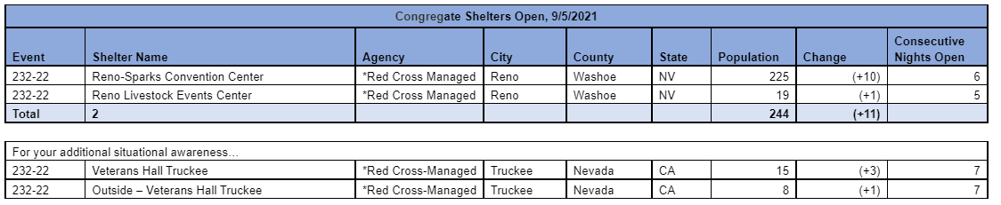
Red Cross continues to manage shelters to support residents affected by expanded evacuations around South Tahoe, CA. Red Cross is currently operating under the planning assumption that approx. 900 individuals would seek congregate sheltering in Nevada (3% of evacuated population). On 9/1 this shelter will expand to a COVID capacity of 908. Red Cross has submitted a resource request to support this shelter with public health staffing, security and wrap around services (shower, toilet, hand wash stations).

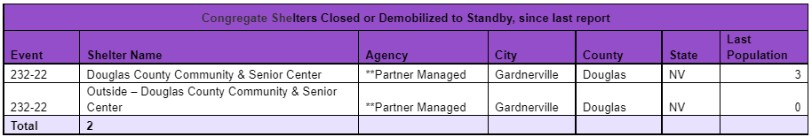

In addition to all congregate (indoor) shelter sites, there are individuals residing outside on the premise (tent, trailer or RV) as reflected in the “Outside” count. This population receives wrap-around services but is not reflected in the congregate shelter count, per Red Cross standard operating procedures.

The Reno Livestock Events Center will be closed in three (2) days due to an event. Mass care is working on a solution on the local level.

Pet sheltering is being coordinated at the Reno Livestock Events Center with support from ESF 11.
ESF 8: Public Health |  |  | Duty Officer: 775-684-5920
Providing COVID tests to shelters and licensure waivers to healthcare workers coming into the state.
ESF 10: Hazmat |  | Rebecca Bodnar: 406-270-6000
ESF 10 has moved to remote contact.
ESF 11: Agriculture |  | William Striejewske: 775-846-1165
ESF 11 has moved to remote contact.
ESF 12: Energy |  |  | Lorayn Walser: 775-230-9851
ESF-12 remains in contact with fuel suppliers and utilities, especially as re-population planning moves forward. Fuel inventory is currently strong. Southwest Gas proactively turned off meters for safety reasons in 3 sections of previously isolated and evacuated areas in South Lake Tahoe, CA. Currently 585 customers presently without natural gas service on the California side of Lake Tahoe. SW Gas has begun to regass the pipeline to one currently shut off section and are prepared to regass the other two zones when Cal Fire says it's safe to do so. SW Gas is also planning for repopulation and restoring service.

NV Energy continues to undertake proactive measures to prevent line and power loss, including pole wrapping on the Muller 1295 line along Foothill Road, removing vegetation along Foothill Road under lines to create a fire break, and continuing working in the Foothill Road and Kingsbury area to remove vegetation. As of 1900 (9/3) the fire was 1.5 miles from NVE infrastructure, specifically the Kingsbury 111 line which has no impact to NVE customers. No NVE customers in Douglas County are without power. and no PSOM events are planned.

ESF 12 has moved to remote contact.
ESF 13: Law Enforcement |  |  | Capt. Bill Murwin: 775-720-8518
Nevada Highway Patrol is supporting local law enforcement at evacuation control points.

Lt. Roth is off duty until Monday, September 6, 2021. Capt. Bill Murwin is supporting ESF 13 from the SEOC.

All personnel who were previously conducting traffic checkpoints are now actively patrolling the area due to the lifted evacuation restrictions and road reopening.
ESF 15: Public Information |  |  | Gail Powell: 775-434-4795
Disseminating re-population information to evacuees on steps to take when returning home.
Public advisory to drive slow in the affected areas, be aware of wildlife, fuel up and obtain household supplies prior to returning home to preserve supplies in the affected areas.
Working on publishing stories on community individuals/businesses that supported first responders and evacuees. Campaign to highlight ESF partners housed in the SEOC, their roll supporting the incident and the importance of their work.

ESF 15 has been coordinating communication between Nevada and California regarding the sudden repopulation effort as well as conducting corrections for misinformation regarding repopulation.

Continuing to disseminate information regarding safe repopulation for all evacuees.

Please see the following attachments for donation efforts regarding various agencies:

El Dorado Community Foundation: https://edcf.fcsuite.com/erp/donate/create?funit_id=1792
The American Red Cross: https://www.redcross.org/donate/cm/abc10-pub.html/.
Placer Food Bank: https://donate.placerfoodbank.org/for/pfb?_ga=2.168769441.1692671111.1585586084- 667740226.1583304010
Food Bank of Northern Nevada: https://give.fbnn.org/for/zcjkyj/
Project Camp: https://projectcamp.co/
El Dorado County Animal Services: https://www.edcgov.us/Government/AnimalServices/pages/pet_aid_fund.aspx

People are being driven to the DEM Social Media for awareness at record levels on the incident receiving thousands of percent increase inactivity and engagement.

Joint Information System has been activated and members have been given assignments. Coordination with CalOES, CalFire and county PIO’s on the California side. Questions for the JIC can be forwarded to 775-687-0395 or communicationrelationspio@gmail.com.
ESF 16: Nevada National Guard |  |  | JOC: 775-887-7200
All Nevada National Guard (55 personnel) have been demobilized.

